Economics – Chapter 6 Notes

Macroeconomic Activity
- Economics is considered to have two branches
- Microeconomics – deals with the economic problem from an individual perspective; studies the behaviour of individual households and firms
- Macroeconomics – deals with the economic problem from society’s perspective; studies the economy as the whole and is concerned with the big picture e.g. economic growth, inflation, unemployment
- Economists distinguish between positive and normative statements
- Positive statements can be tested against fact
- Normative statements cannot be tested as they reflect personal opinions or values

Why study macroeconomics?
- Develops ‘economic literacy’, the ability to understand economic events and make decisions on a personal level
- To understand how the government makes good economic decisions
- To enable us to compare Australia to other countries
- Enables us to see how Australia is performing over time

The Circular Flow of Income
- A macroeconomic model that describes the flow of resources, goods and services, and income between parts of the economy
- The model divides the economy into important sectors – households, firms, the financial sector, the government sector and the overseas sector

Households and Firms
- Assumes that households are the owners of the productive resources (land, labour, capital and enterprise) and the buyers of final goods and services
- Assumes that firms are the employers of resources and produce all the goods and services for the economy
- Shows the exchange to satisfy needs and wants
- Money flow – spending and income (outer)
- Real flow – goods, services and resources (inner)
- Factor market – Households receive income in the form of wages, rent, interest, dividends and profits form the resources they supply to firms for use in the production process
- Product market – Households spend the income they have earned in exchange for goods and services that have been produced by the firms sector

Savings and Investment (The Financial Sector)
- Most households try to save some of their income
- The financial institutions that make up the capital market act as an intermediary between savers and investors
- Savings – the proportion of household income not spent on goods and services for current consumption
- Savings represent a leakage from the circular flow as it reduces the flow of money and goods between households and firms
- The financial institutions (banks, credit unions, superannuation) form the financial sector
- Investment – defined as expenditure on goods and services which are not intended for current consumption
- Investment is firms spending on capital equipment that will be used to produce goods and services in the future
- Creates an increase in the flow of income in the flow
- Investment is an injection that offsets the savings leakage in the circular flow

The Government Sector
- The government buys goods and services from businesses
- As a producer it also provides education, health and defence
- Transfer payments – the provision of social welfare such as pensions, the job search allowance and childcare allowance
- Governments regulate economic activity to promote equity and efficiency
- Households pay some of their income to the government (taxation leakage) which is returned to the flow through government expenditure
- The government sector collects taxation from households and spends those funds to provide goods and services for collective consumption or transfers e.g. social security
- Taxation is a leakage from the flow of income between households and firms; government spending is the injection by which funds are returned to the flow (government expenditure)
- Government spending can be classified as either current expenditure (wages, salaries, fuel, power) or capital expenditure (infrastructure – schools, roads, hospitals)

The Overseas Sector
- An open economy is an important contributor to our economic well-being; trade allows us to buy items we cannot produce ourselves and foreigners to buy products that they cannot produce with their resources
- Imports are a leakage from the circular flow, exports are injections
- Imports – money flows from Australia to overseas
- Exports – the flow of money from overseas to Australia
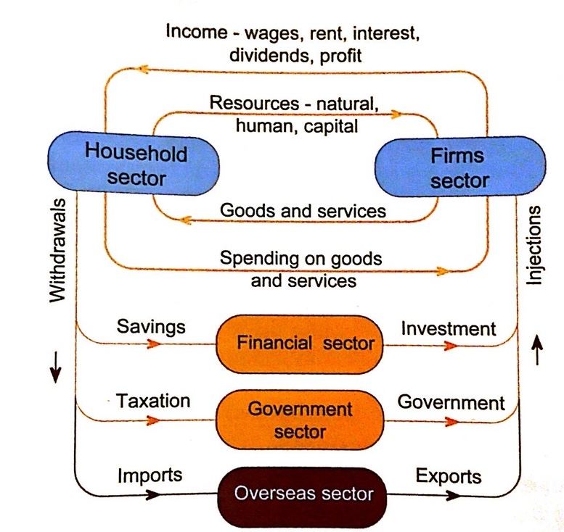
The Full Circular Flow Model
The full model recognises:
- A capital market (the financial sector) – matches the needs of households with surplus income and firms that borrow for investment
- The government provides many community needs (financed by taxes)
- Trade with other countries provides for the needs we cannot produce our self in return for goods and services that are surplus to our needs
- The model gives us an overview of the interdependence between the major sector of the economy

Macroeconomic Equilibrium
- The value of output produced by firms must equal the value of income paid to resource owners, which must in turn equal the value of spending by
- households to produce the output

Equation: ΣO = ΣY = ΣE
- O = output
- Y = income
- E = expenditure
- Equilibrium – no tendency for the level of income in the economy to change
- Inequalities are a powerful force in causing fluctuations in the level of economic activity
- For equilibrium in the full circular flow, the sum of the withdrawals/leakages must equal the sum of injections
- S + T + M = I + G + X

Changes in Leakages and Injections
- When total leakages are greater than injections, the producer output and household income will fall, this means the economy will contract
- When total injections are greater than leakages, household income and producer output will rise; this means the economy will expand
- Textbook Example:
- When I>S the economy is not at equilibrium
- Total expenditure > current output and income
- The new investment expenditure expands the output of the firms sector in the next time period
- Thus, income will also rise
- The economy will continue to expand until a new, higher equilibrium is reached and S = I again at a higher price

Aggregate Expenditure
- The total amount that firms and housed holds plan to spend on goods and services at each level of income
- AE = C + I + G1 + G2 + (X-M)
- C = Consumption
- I = Planned investment expenditure
- G1 = Current Government expenditure
- G2 = Capital Government expenditure
- X = Exports
- M = Imports

ELEMENT |  | SIZE | DESCRIPTION
Consumption | C | Approximately 60%, least volatile | Expenditure on non-durable goods, expenditure on services, expenditure on consumer durables
Planned Investment | I | Approximately 15-20%, most volatile | Expenditure on new capital equipment which produces final goods in the future (machines, factories, tools); expenditure on building and housing
Government | G | Approximately 25% | G1 – Current expenditure – wages  G2 – Capital expenditure – roads, schools
Net Exports | X-M | Approximately -1-2% | Value of exports minus imports

Consumption
- Consumption → expenditure on non-durable and durable goods and services
- Nondurable goods → consumed quickly after purchase i.e. food, clothing transport (approximately 35%)
- Durable goods → are expected to last for three or more years such as whitegoods (washing machine or fridge) or brown goods (furniture, carpets) (approximately 15%)
- Services → non-commodity items such as education, health and recreation. (approx. 50%)
- Expenditure on household necessities is quite stable no matter the stage of the business cycle i.e. boom or recession
- Expenditure on durable goods and luxuries much more likely to vary due to state of economy due to larger sums of money involved
- People will adjust saving patterns than their consumption of basic needs

Private Investment
- Spending by firms that includes:
- fixed investment (privately funded expenditure on equipment and structures used in production)
- residential fixed investment (private expenditure on new housing)
- Most volatile component of AE as it involves risk and will respond the where the economy is in the business cycle and the resulting business conditions

Government Expenditure
- Includes all federal, state and local spending on final goods and services, and investment in capital equipment and infrastructure
- G1 – Current expenditure that provides for the day to day functions of government
- such as government employee wages
- G2 – Capital expenditure to provide for future needs such as schools, roads, power, communication, dams

Net Exports – Exports - Imports
- Net exports is shown in brackets because exports and imports are actually consumption, investment or government spending
- The minus sign suggests the aggregate value of imports exceed the value of exports

Factors Affecting Consumption
- Level of disposable income (Yd)
- Expectations
- Cost of Credit / Interest
- Personal Wealth
- Government Policies

- Level of disposable income (Yd) → Other things being equal households spend more on consumption at higher income levels; income after taxes
- Expectations → Expectations are positive or negative sentiments (feelings) people have about the economy in the future. More positive their expectations the higher their consumption especially on durables
- Cost of credit (interest rates) → credit allows purchasing decisions to be bought forward. Falling interest rates means lower cost of money and greater consumption. Rising interest rates means cost of money rises, more is spent in repayments on borrowings and saving becomes more attractive, decreasing consumption
- Personal Wealth → The wealthier households feel the more they tend to consume i.e. holders of property and shares feel more wealthy
- Government Policies → Fiscal Policy (taxation and govt spending through budget) affect disposable income levels which affects consumption. Monetary policies (RBA) affects interest rates and therefore cost of credit and money

Factors Affecting Investment
- Risk
- Rate of interest
- Business expectations
- Profitability
- Government Policies

- Risk → investment rises and fails depending on perceived risk. Higher the risk the less likely the investment. Political decisions, international events, changes in consumer tastes all affect risk.
- Rate of Interest → Rate of interest and investment are inversely related. Reasons are:
- When interest rates are rise so too does the repayments for capital funds bought with borrowed funds.
- Interest rates represent the opportunity cost of money. As interest rates rise the opportunity cost of investment increases because the money could be used for other purposes than investment.
- Nominal interest rates (current price of borrowed money) are not as important as real interest rates (take into account inflation) when determining investment.
- For example, if current mortgage rates are 8% and the current inflation rate is 3% then the real rate of interest being paid is 5% (8% - 3% = 5%).
- Business Expectations → What businesses think about current economic activity, trends for the future and the impact on profitability.
- Formed as result of current economic events such as levels of sales and enquiries from buyers.
- High consumption accelerates investment decisions as more capital goods are needed to produce more goods and services.
- High expectations will shift the investment demand curve to the right.
- Profitability → Many firms retain a portion of profits for investment. When profits are low, firms tend to run down capital equipment rather than invest. Business fixed investment seems to lag about a year behind corporate profitability in Australia.
- Government Policy → Affects investment directly and indirectly. Fiscal and monetary policy affect investment because they affect business costs i.e. taxation and economic activity. Can directly target investment with incentive for business to invest i.e. subsidies and tax allowances. Government regulations affect market structures and competition and therefore decisions to invest i.e. microeconomic reform.

Factors Affecting Government Expenditure
- Tend to be stable from year to year. Basic programs i.e. health and education cannot be changed much in real terms
- Changes in the business cycle cause government as a macroeconomic manager to make discretionary changes in taxation and expenditure i.e. $42B Stimulus package in 2008-9
- Some government vary in line with economic conditions. For example, in a trough, welfare payments rise

Factors Affecting Net Exports
- Exports can be quite volatile as Australia relies on trade and is influenced by overseas economic activity i.e. China’s demand for minerals
- Agricultural production is subject to change due to differences in seasons
- Overseas demand for agricultural commodities fluctuates according to overseas economic conditions
- High levels of economic activity in Australia increase purchasing of imports
- Exchange rate. As the $A value appreciates imports become cheaper and exports more expensive

Changes in Investment and Consumption
Investment is seen as a more volatile (unstable) component of aggregate demand than
consumption because:
- Investment is based on confidence and expectations which are subjective and unstable
- There is a smaller base level of investment than consumption (approximately $110b to approximately $330b) yet it often takes more dollars of investment to generate a set level of production (and potential consumption).
- Producer goods are durable and can be repaired ‐ replacement can be postponed until times are more promising.
- Some non-durable basic consumption is necessary for ‘survival’.
- Technological advance and new investment opportunities occur haphazardly or unpredictably.

Economics – Chapter 7 Notes

The Business Cycle
The business or economic cycle is the shorter-term fluctuation of total output around its trend path. Some years countries experience higher than average rates of growth i.e. boom and in others lower than average growth i.e. recession. The cycle will vary in length and amplitude making it highly irregular.

The Trend Path
- For an economy to achieve sustained growth there must be a sustained increase in capacity or potential output
- This is essentially a supply side issue involving use of more resources, better resources or using resources in a better, more productive, way
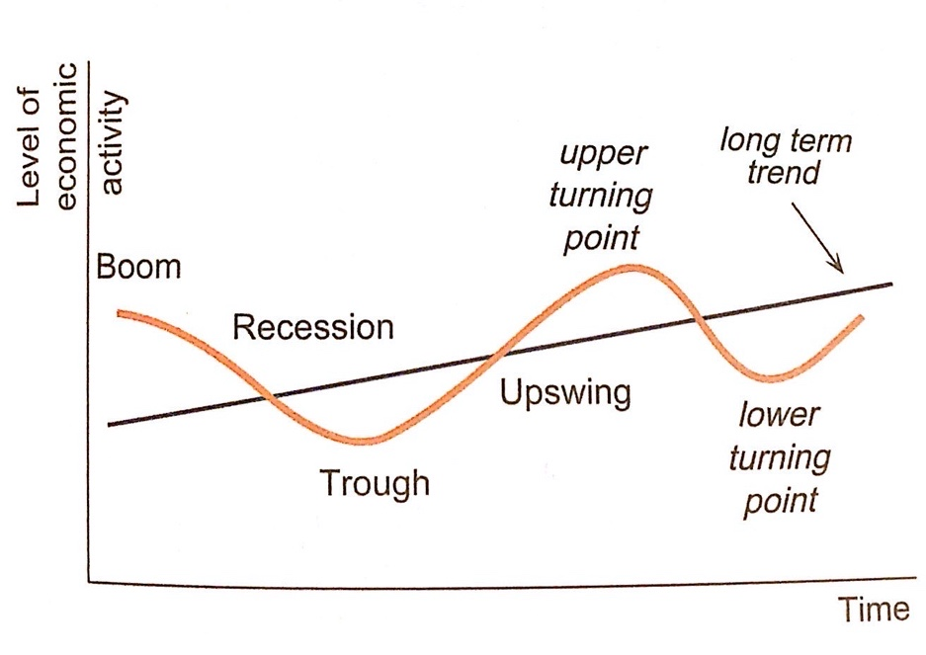
Four Phases of the Business Cycle
- Boom (peak) phase
- Downswing (contraction)
- Trough phase
- Upswing (expansion phase)

Model vs Reality
The actual economy shows a greater degree of instability and its quarter by quarter movements are unpredictable. A model simplifies things to make it easier to understand.

Business Cycle & Aggregate Demand
- Movements away from this trend line are essentially a demand side issue.
- If demand outstrips the ability of the economy to supply (a boom)
- If demand will fall below the potential level of output (a recession).

Characteristics of Each Phase
Booms → occur at the peak of the cycle. The boom is a period of rapid economic growth, with growth a good way above its trend level. Booms are unsustainable.
Characteristics:
- High levels of consumption expenditure particularly on durable goods and
- luxuries.
- High levels of consumer and business confidence
- Business relatively profitable
- Firms have little excess capacity
- Cyclical unemployment relatively low (full employment)
- Participation rates high
- Inflation pressure more likely
- Imports are relatively high increasing the CAD
- Level of borrowing high

The Downswing (contraction) → in the economy is a period when growth rates slow down,
growth rates start the period above trend levels but end up below trend levels.
Characteristics:
- Aggregate expenditure fall as Consumption and Investment decline
- Levels consumer and business confidence fall
- Business profitability starts to fall
- Inventories rise above desired levels
- Falling output and income
- Inflationary pressures declines
- Unemployment starts to rise
- CAD declines as import fall
- Level of borrowing starts to fall as costs of borrowing are high and investment is riskier due to capacity constraints.

The Trough (Recession) → in the economy is a period the level of aggregate expenditure is below the economy’s potential.
Characteristics:
- Higher levels of cyclical unemployment.
- Lower levels of company profits.
- Slower rates of consumption
- Lower levels of consumer and business confidence.
- Savings may rise as people put off consumption decisions (especially if their job is at risk)
- Interest rates and inflation bottom
- Firms have maximum idle capacity
- CAD declines as imports fall

The Upswing → the growth rate climbs up above the trend rate again.
Characteristics:
- Investment increases as productive capital requires replacement
- Economic growth begins to rise
- Levels of expenditure, income and output increase
- Inflation starts to rise
- Unemployment remains high then starts to fall
- Consumer and business confidence start to rise
- Level of borrowing starts to increase
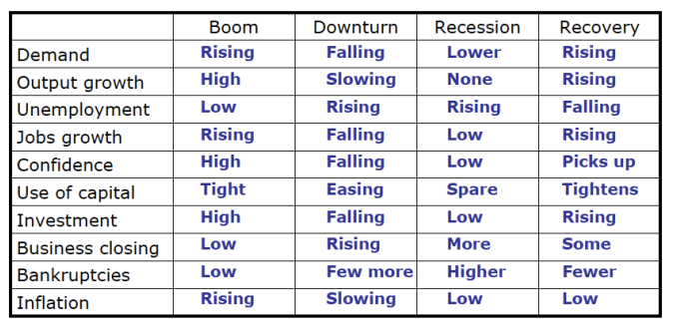
- Business profitability starts to rise

Indicators of Economic Activity
Economic Indicator → refers to any piece of data or information that can be used to help build a picture of where the economy is and where it is going
- Most important indicator is Gross Domestic Product (GDP) → provides key summary of economic trends
- Examples:
- Consumer Price Index (CPI)
- Average weekly earning (AWE)
- Labour force and unemployment statistics
- Business spending on capital equipment (i.e. investment)
- Motor vehicle registrations
- Building approvals
- Interest rates
- Exchange rates
- Stock market
- Debt levels

Leading Indicators → predict trends in economic activity. We expect them to change before a direction becomes evident in the rest of the economy.
- Examples:
- Building approvals
- Share market
- Levels of inventory by firms
- New employment vacancies
- Business confidence
- Consumer sentiment

Coincident Indicators → appear to move in line with the level of economic activity.
- Examples
- Growth of real GDP
- Interest rates
- Sales of consumer durables
- Retail sales
- Manufacturing output
- Production of building materials

Lagging Indicators → not expected to show any change until after trends in the rest of economy have been confirmed. They react to developments that have helped in the past.
- Examples
- Unemployment levels
- Savings bank deposit levels
- Consumer debt levels

Economics – Chapter 8 Notes

Economic Growth
Economic Growth → the increasing capacity of the economy to satisfy the material wants of its members; enables households to achieve a higher standard of living in material terms

Macroeconomic Objectives
There are three main economic objectives that the government tries to achieve in the economy.
- Sustainable Economic Growth → Increasing economic capacity of the economy to satisfy the material wants of its members; sustainable economic growth refers to a rate of growth which can be maintained without creating other significant economic problems for future generations – TARGET 3-4%
- Price Stability → Low levels of inflation; achieving price stability is important because inflation adversely affects many aspects of our economy – TARGET 2-3%
- Full Employment → Everyone who is willing and able to work can find employment; the natural rate of unemployment – TARGET 4-5%

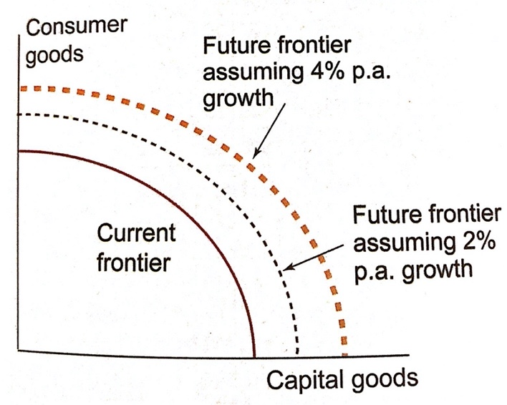
Economic Growth and the Production Possibility Frontier
Higher rates of economic growth expand the nation’s opportunity set in the future. The production possibility frontier is a model which shows all the combinations of output which an economy can produce using its available resources at a point in time. The solid line shows the current opportunity set for the economy. If the economy grows at 4% per annum in the future, it will be able to achieve higher levels of output and material welfare than it could achieve if the average rate of growth was 2% per annum. Thus, current rates of growth affect future production and consumption possibilities for the community.

Measurement of Economic Growth
- Gross Domestic Product (GDP) → defined as the total market value of all final goods and services produced in a country in a period of time (usually a year).
- Nominal GDP → gross domestic product expressed in todays prices.
- Real GDP → gross domestic product with inflation removed.
- Real GDP Per Capita → gross domestic product divided by population. This is the most meaningful measure of economic growth as it represents society’s ability to satisfy the wants of its members.

Calculating Economic Growth
GDP by itself is of little relevance. It is the growth in output that is important, as represented by the rate of change in the rate of GDP. This calculation works out, as a percentage, how much GDP as increased from one year to the next.

Economic Growth = GDP (Year2) – GDP (Year1) x 100
GDP (Year 1)

E.g. 1
- GDP Year 1 – $1,750,000,000
- GDP Year 2 – $1,895,000,000
= 8.3%
E.g. 2
- GDP Year 1 – $1,456,000,000
- GDP Year 2 – $1,413,000,000
= -3.0%

Rates of Economic Growth Year on Year (YoY)
- Australia in 2007: 3.75%
- Australia in 2009: 1.5%
- Australia in 2011: 2.5%
- Australia in 2013: 2.6%
- Australia in 2015: 2.3%

Limitations of GDP as a Measure Of Economic Welfare
- Does not measure distribution of growth: GDP doesn’t adjust for the distribution of goods. For example, economy 1 has a ruler who gets 90% of what is produced, and everyone else survive on what’s left (10%). Economy 2 = the distribution is considerably more equitable, and everyone is distributed the same amount. In both cases GDP would be the same per capita, however GDP does not measure the distribution of the growth. The people in our society that benefit most from growth tend to be the owners of non-labour resources, workers in growing sectors of the economy and workers who are occupationally and geographically mobile.

- Does not account for non-market production: Goods and services produced but not exchanged for money, known as ‘nonmarket production,’ are not measured, even though they have value. For instance, if you grow your own food, the value of that food will not be included in GDP. If you decided to watch TV instead of growing your own food and now you have to purchase it, then the value of your food would be included in GDP. What you choose impacts your GDP.

- Does not measure changes in overseas relationships: GDP does not measure the changes in overseas relationships. Changes could be made to an economies overseas relationship that majorly impact the country’s economy however the GDP does not measure the changes in overseas relations.

- Does not measure quality of life: GDP is not a measure of a nations well-being. GDP is not a measure of the overall standard of living or wellbeing of a country. Although changes in the output of goods and services per person (GDP per capita) are often used as a measure of whether the average citizen in a country is better or worse off, it does not capture things that may be deemed important to general well-being. GDP does not have to take into account leisure time, nor is considering how hard people work to produce output.

Sources of Economic Growth
- The rate of population change.
- The rate of increase in capital equipment per worker.
- Technological progress and the application of new ideas in the production process.
- Improvements in the skills and productivity of the labour force.
- The size of the natural resource base.
- The capacity of an economy to change.
- The willingness of an economy to trade with overseas economies.

More efficient use of resources is an important source for long-term economic growth. Increasing efficiency in the production of goods and services will increase the supply. The long-term trend line of economic growth in the Business Cycle model will rise if efficiency increases.

There are three types of efficiency:
- Technical Efficiency – productivity given fewest inputs/resources necessary
- Allocative Efficiency – where production meets consumer preferences/ where goods and services are distributed according to these preferences
- Dynamic Efficiency – involves improving efficiency over time. Relates to how fast firms/industries can respond to changes in market conditions or technology

Foundations of Australian Growth
Natural Resources
- Natural resources are often the foundation of economic growth in the early stages of a country’s development. In Australia’s case, the contribution of natural resources to economic growth was greatest in the later part of the 1800’s, when the gold boos occurred and land was cleared for agriculture and pastoral industry.
Human Resources
- Technology in the sense to improve the quality of the labour force means ideas that improve the quality of the human resource. This is often called human capital defined as the stock of knowledge and skills that people develop through education and experience
Investment and Capital
- Capital widening – the stock of capital is widened when it grows in proportion to other productive input. Firms buy capital equipment in order to produce final goods and service
Technological Progress
- Changes in scientific and technical knowledge which involve new discoveries and new techniques

Benefits and Costs of Economic Growth
BENEFITS
  - Higher real incomes per capita and living standards can be realised due to increases in productivity and resource use. Higher real incomes raise purchasing power and thus living standards through improvements in material welfare.
  - Higher levels of economic growth encourage higher levels of savings.
  - Higher levels of economic growth tend to lead to increased levels of productivity and technological progress since resources are used more efficiently as producers cut costs and innovate to keep pace with rising demand for goods and services.
  - Higher rates of economic growth that results in employment creation and falling unemployment levels also leads to higher incomes for those previously unemployed. Growth may create more opportunities for underemployed workers.
  - Economic growth, which generates higher GDP also, leads to increasing taxation revenue for the government. Governments can use this taxation revenue to provide social and economic infrastructure and to fund the social security system for the provision of welfare payments.
  - Higher levels of economic growth can contribute to new business investment. New investment opportunities in resource projects and capital equipment may result from higher sustained economic growth.
  - Economic growth involves increases in real output, some which may be exported. Export income can then be used to finance imports of capital and consumer items. The gains from trade include higher living standards.
  - A nation which high rates of economic growth is more likely to be able to reduce the extent of absolute poverty.
  - Economic growth permits improvements in social welfare including:
- Benefits to personal lifestyles from greater real income.
- Additional leisure time that workers may trade off for extra work as incomes rise. This enables Australians to use leisure time, and thus develop new industries.

COSTS
- A problem experienced by economies in pursuing high rates of economic growth is externalities, or the damaged caused by the natural environment through pollution, and land degradation. Most natural resources are required to sustain high growth rates and a depletion of non-renewable natural resources and decline in environmental quality may be associated with high rates of economic growth.
- Economic growth is a vehicle for great technological and structural change in production, which can lead to structural unemployment of labour. Governments need to fund retraining schemes, to reskill the unemployed.
- Economic growth can lead to an emphasis on materialism and consumerism.
- Economic growth may lead to a widening in the inequality in the distribution of income and wealth in society if the benefits of growth do not trickle down to all classes but concentrated on high-income groups.
- Excessive rates of economic growth can lead to demand pull and cost inflation as resources become scarce in relation in increased demand. Economic growth may interfere with price stability. It can also conflict with full employment as technological progress leads to structural unemployment.
- Increases in the Current Account Deficit as demand for imports increases as economic growth increases.

BENEFITS | COSTS
Increasing real income and material wealth  More economic opportunities  A taxation dividend to government  Higher quality of goods and services | May not raise the living standards of everyone in the community  It’s associated with structural change in the economy  May bring inflationary pressure  Has social costs  Is associated with economic ‘bads’ as well as ‘goods’

Economics – Chapter 9 Notes

Inflation
Inflation is a persistent and appreciable rise in the general level of prices. Describes noticeable price increases that occur over time and across a range of goods.

Measurement of Inflation
Consumer Price Index (CPI) – an index number that records changes in the general level of prices

Steps in Calculating CPI
  - The CPI is based on a basket of goods and services that are classified into eleven major groups, 33 subgroups and 87 classes of expenditure; standard buying of a metropolitan household
  - The ABS attaches a weight to each commodity in the CPI basket in order to reflect its importance in the pattern of expenditure in an average household. The weights are a positive statement about the observed spending patterns of households.
  - Measured every three months
  - The weight is then multiplied by the price of that item to describe how much an average household would have spent in a period of time.
  - Total expenditure in each period is then calculated.
  - Period 1 is the base period allocated the index number 100. The base periods is that to which others will be compared.
  - To calculate the price index for period two, the total household expenditure for that period is expressed as a proportion of expenditure in the previous period.
  - The rate of inflation is simply the rate of change in the price index from one period to another.

The rate of inflation: = CPI (Year2) – CPI (Year1) x 100
CPI (Year 1)

Rates of Inflation Year on Year (YoY):
- Australia in 2007: 2.3%
- Australia in 2009: 1.7%
- Australia in 2011: 3.3%
- Australia in 2013: 2.5%
- Australia in 2015: 1.5%

Types of Inflation
Headline Inflation → Inflation rate including all items in the CPI (generally what is reported in the media); is a broad measure of changes in the cost of purchases made by households in capital cities
Underlying Inflation → Inflation rate excluding volatile items from the CPI such as fruit and vegetables and the retail price of petrol. This is a more accurate measure of inflation as movements in some groups are influenced by short term factors such as agricultural commodities (when things are out of season) and economic policies – falling interest rates, taxes on certain goods etc.

Limitations of the CPI
- Only reports price movements in metropolitan areas and families
- Not regarded as a true cost-of-living index because it does not reflect changing consumer preferences or the substitutions which consumers make from day to day in response to relative price changes (e.g. consumers buying apples rather than bananas if the price of bananas rises due to a cyclone)
- Cannot account for changes in the quality of goods over time and is likely to overstate price increases
- Doesn’t take into account all goods

Causes of Inflation
Figure 1
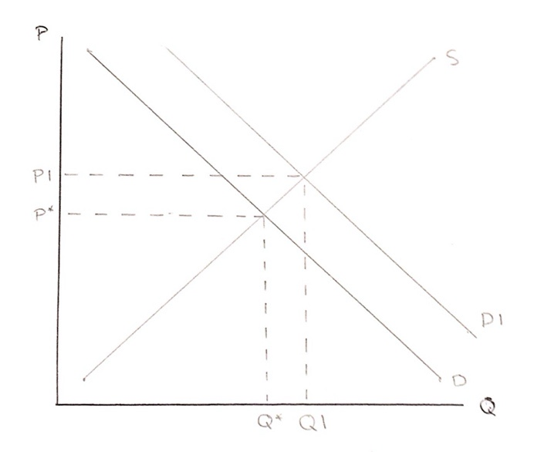
Demand Pull Inflation → Demand pull inflation is a type of inflation when high levels of demand are caused by high levels of aggregate expenditure. This can occur when there is excess demand for the resources available at a time. High levels of demand for limited resources implies competition for these resources, forcing prices to rise. This may apply to both producer and consumer goods and some industries are affected more than others. As shown in Figure 1, when demand increases from D to D1, quantity demanded rises from Q* to Q1 and price increases from P* to P1. This creates a new equilibrium at P1 and Q1. This occurred during the 2011 mining boom when inflation in Australia rose to 3.3% due to high levels of demand for goods and services in the economy because of increasing incomes.

High levels of aggregate demand are indicated by:
- High levels of spending on construction and consumer durables such as furniture and whitegoods (generally associated with upswing and boom periods)
- Excess demand for labour in some sectors of the economy, forcing wages up in those sectors and thus prices
- Excess money supply – when the growth rate of money supply is faster than the rate of growth of real output
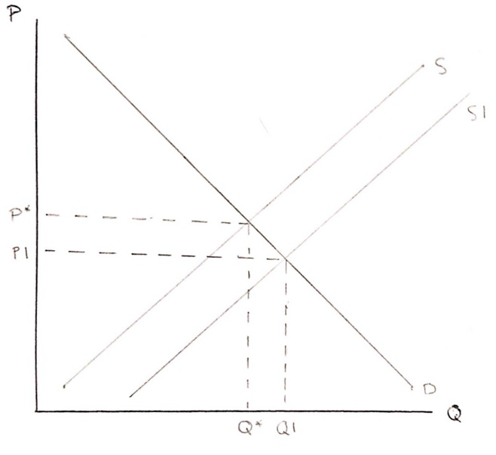
Figure 2
Cost Pull Inflation → Cost push inflation occurs when rising production costs are passed on to consumers, who then pay higher for final goods and services. Costs reflect the prices paid for productive inputs. Periods of cost push inflation can be attributed to increases in the prices of significant productive inputs. In Figure 2, quantity supplied decreases from S to S1 as price rises from P* to P1 causing demand to fall from Q* to Q1. For example, large rises in fuel prices as a cost of production could cause produces to raise their prices because of cost push inflation.

Significant productive inputs include:
- If wages increase faster than worker productivity
- If the prices of imports rise, perhaps as a result of depreciation of the domestic currency
- If oil prices rise – oil being a significant cost component in production and distribution
- If household energy prices rise in practice, it is difficult to distinguish demand pull and cost push instances of inflation.

In practice, it is difficult to distinguish demand pull and cost push instances of inflation.
Consequences of Inflation
The effects of inflation can be categorised into two areas – level of output, income and employment and secondly the distribution of income and wealth in the economy.

Output Effects:
- Real incomes – will decrease as purchasing power decreases; households cannot purchase the same volume of goods and services as they were able to in the past as prices rise faster than income
- Economic efficiency – tends to decrease as people start to invest in speculative assets (property, gold, art) by trying to hedge against inflation; these are non-productive resources, efficiency over time falls as this money didn’t go into increasing production
- Uncertainty – high levels of inflation promote uncertainty; cause consumer and producer confidence to fall as they become uncertain about their purchasing decisions; both saving and investment are discouraged – more risk involved
- Capital for Labour Substitution – wages increase so business will move away from more expense labour resources and will swap to machinery
- Lack of confidence – relates to uncertainty; confidence falls as people worry about where the economy is heading which affects aggregate demand; causes a lack of confidence in money as a store value
- Real interest rates – inflation taken out; real interest rates fall
- International competitiveness – Australia becomes less competitive to overseas competitors; a country is at a disadvantage if domestic inflation is greater than competitors; demand for exports fall
- Hyperinflation – when inflation gets out of control, it can cause the economy and currency to collapse; people lose confidence in money as a measure of store value

Redistribution Effects:
- Holders of assets – value of the assets will rise with inflation so they become more wealthy
- Income earners – people on fixed wages or pensions lose out as the value of money decreases, someone as part of a strong union and have bargaining power will be ok
- Creditors and debtors – creditors are paid back with inflated dollars which are not worth as much so they too lose out; debtors are advantages as they are paying back with inflated dollars (interest rates helps with this problem)
- Taxpayers – bracket creep – pushes people up into higher tax brackets so they have to pay higher taxes whilst their purchasing power decreases; gradually causes a person’s income levels to rise to levels where they are liable for higher marginal rates of taxation (government revenue increases)

Groups that gain with high inflation:
- Holders of assets
- The government
- Debtors

Groups that lose with high inflation:
- People on fixed wages or pensions
- Creditors
- Taxpayers

Economics – Chapter 10 Notes

Unemployment
- Unemployment → People in the labour force who are willing and able to work but cannot find a job.
- Labour force → People who want a job. They are in work or are actively looking for work and able to start work (looking for work, working, ready to start work and want to work). Both the employed and the unemployed are in the labour force.
- Participation rate → Proportion of people of working age who are in the labour force.
- Unemployment rate → Proportion of the labour force without a job.

Rates and Levels
The unemployment rate is the percentage of people in the labour force without work
= unemployed x 100
labour force
The level of unemployment is the number of people without work.

The participation rate is calculated by:
= Labour force x 100
Population 15+

ABS Criteria
To be officially unemployed, and therefore entitled to benefits, people have to prove they are:
- Doing less than 1 hour paid employment per week
- Actively looking for work (keeping a job search diary)
- Able to start work
- Wanting to work

People not in the labour force includes:
- People under the age of 15
- Retired individuals
- Full-time students
- People who perform home duties
- Those who are ‘chilling out’
- Individuals in the armed forces

Measurement Issues
- Data based on telephone sample:
- Is the sample representative?
- People tend to give more false information the longer they are in the sample
- Official figures don’t include
- Hidden unemployed (200,000 people may have dropped out of the labour force). They are discouraged workers, who, pessimistic about finding a job, leave the labour force
- Disguised unemployment (6.4% (575,000) people want to work longer hours – these people are neither unemployed nor employed to the degree they want
- Official figures do include
- Cruising people, not really after a job but somehow still getting benefits
- Not a measure of the true state of the labour market due to;
- Overtime – hours at work have been increasing at the workers suffering
- Insecurity (contracts and casualisation) – higher levels of ‘churning’
- Earning differentials – rich get richer, fewer middle-income jobs
- Uneven distribution of employment
  - Rise in jobless households and multi-income households
  - Regional differences (rural vs city, low income cities vs high income cities)
  - More long-term unemployment (1 year+)
  - Mean period of unemployment 19 weeks (10 in 1970s)

Unemployed typically are >50, sole parents, indigenous Australians, people with disabilities and migrants with English as their 2nd language

Other measurements of the state of the labour market could include:
- Employment growth data
- Wage data
- Hours worked data
- Skilled labour shortages
- Changes in participation rate (rises when labour is short)

A fall in the participation rate may lead to a lower unemployment rate – a rise in the participation rate may lead to more employment and a rise in unemployment rate at the same time.

Unemployment Rate, Employment and the Participation Rate
- A fall in the participation rate will, other things being equal, cut the unemployment rate.
- A cut in the unemployment rate might encourage more workers to join the labour force
- Employment and the unemployment rate can both rise if the participation rate rises

Causes and Types
Structural → Change in pattern of demand, immobility in labour force. Includes technological, seasonal
Frictional → Churning. Temporary unemployment as people move from job to job.
Cyclical → Too low level of aggregate demand to provide work for labour force

The Pool of Unemployment
- If the inflows (newly unemployed) match the outflows (people getting new jobs or leaving the workforce) the level stays the same.
- If the inflows (newly unemployed) are greater than the outflows (people getting new jobs or leaving the workforce) the level rises.
- Some of the newly unemployed lost their jobs because of a drop in aggregate demand. This is demand-deficiency, general or cyclical unemployment
- Some of the newly unemployed lost their jobs because of a change in the pattern or structure of production and employment. This is structural unemployment.
- This may be due to new technologies creating some jobs but destroying others.
- This may be due to changes in demand for Australian made products because of tariffs changes and opportunities in the global economy.
- Some swim quickly to the other side and get out. These are frictionally unemployed.
- Some sink to the bottom. They are residually unemployed.
- Some can’t swim very well and they get stuck in the pool for a long time. They are long term unemployed.

Cyclical or Demand Deficient Unemployment
- Demand deficiency unemployment occurs when output is below full capacity (or where AD is below the level needed to get output to capacity)

Structural Unemployment
- Structural unemployment arises from the mismatch of skills and job opportunities as the pattern of demand and output changes.
- Change in the structure or pattern of production and employment
  - Competition from China
  - Trade liberalisation (Globalisation) e.g. textile, clothing and footwear
  - Changes in consumer demand (e.g. unhealthy foods)
  - New technologies replace workers (e.g. secretaries)
  - Microeconomic Reform (government business (e.g. Telstra) getting more efficient)
- Workers can’t or won’t switch into new job areas (they are occupationally and/or geographically immobile)

Frictional Unemployment
- People change jobs but are temporarily out of work in-between jobs. They experience short spells of unemployment as they hop between jobs in a dynamic society.
- Frictional unemployment is the irreducible minimum unemployment in a dynamic society.
- Will rise when growth is high, when the labour market becomes more flexible (more churning)

Underemployment
- When people are employed but are willing to work more hours. For example, if someone is working 10 hours a week but would be willing to work 40 hours a week.

The Natural Rate of Unemployment
- The natural rate is the core or equilibrium level of unemployment. It is the level of unemployment when the labour market is in equilibrium.
- At the natural rate cyclical unemployment is zero. The natural rate, therefore, is made up of the other types of unemployment.
- The natural rate of unemployment could be thought of as the level of ‘can't-do-much-about-it-by increasing-demand’ level of unemployment. If the government tries to run the economy at a level where unemployment falls below the natural level there is in a sense over-full employment.

NAIRU
- NAIRU = The non-accelerating inflation rate of unemployment.
- With over-full employment wages will start to rise (there will be shortages of people with particular skills).
- So, as unemployment falls below the natural rate wage inflation picks up, and the economy is clearly below the NAIRU rate.

CONSEQUENCES FOR THE ECONOMY
COSTS | BENEFITS
Opportunity cost of ‘lost’ production  Skills atrophy | Lower inflation – a pool of unemployed keeps wage increases down
CONSEQUENCES FOR GOVERNMENTS
COSTS | BENEFITS
Lost tax revenue  Costs of transfers (unemployment benefits)  Cost of job creation and job readiness schemes  Extra demand on government services | Control of inflation
CONSEQUENCES FOR INDIVIDUALS
COSTS | BENEFITS
Loss of income  Loss of status, position in society  Loss of self-esteem  Loss of work habits, job readiness  Boredom (Loss of friends, loss of purpose)  Poorer health (Lost nutrition, stress)  Family breakdown  Unhappiness (The unemployed are apparently amongst the least happy individuals in the population) | More leisure time (Yet involuntary)  Transfer payments (Not high amounts)  In better position to take up good opportunity
CONSEQUENCES FOR SOCIETY
COSTS | BENEFITS
The moral dimension – people can’t fully participate in society  Crime  Bigger income differences  Loss of useful products/GDP gap | None

Paragraphs on Types of Unemployment
The first type of unemployment is cyclical unemployment. Cyclical unemployment occurs when there are too low levels of aggregate demand to provide work for the labour force and output is below full capacity. Cyclical unemployment occurs when people lose their jobs because there is no need for their work due to lack of demand as it coincides with the business cycle. For example, high levels of cyclical unemployment occurred during the GFC because aggregate demand fell significantly.

The second type of unemployment is frictional unemployment. Friction unemployment is the temporary unemployment as people move from job to job. Individuals experience short spells of unemployment as they hop between jobs in a dynamic society. This can include people waiting for a new job or gaining more qualifications. Furthermore, it will rise when growth is high as the labour market becomes more flexible. For example, if an electrician from Busselton is moving to Perth, the short time between jobs is frictional unemployment

The third type of unemployment is structural unemployment. Structural unemployment arises from the mismatch of skills and job opportunities as the pattern of demand and output changes. Workers can’t or won’t switch into new job areas as they are occupationally or geographically immobile. This includes unemployment caused by technological advancements and changing seasons. For example, a ski instructor who works in the snow season (winter) will be structurally unemployed during summer when temperature is higher.

Economics – Chapter 11 Notes

Balance of Payments
Australia is linked to the global economy through the flow of goods and services, the flow of financial capital and the flow of people including tourists, students, workers and migrants. Australia gains economic benefits from participating in the global economy as well as political, social and cultural benefits. Australia also relies on foreign investment – the inflow of foreign savings, which helps to fund our domestic investment needs. Rapid developments in transport and communications have enabled people to interact with the global economy on a daily basis. The exchange of goods and services is an important characteristic of any specialised economy. Specialisation and trade enable people to achieve a higher standard of living.

Pattern of Australia’s Trade
- The direction of our trade is reflected in our close proximity to the Asia-Pacific region
- The composition of our trade, reflects the nations natural resource wealth
- Primary exports (resources and rural) account for 60%
- Service exports have been increasing over time
- Largest imports are personal travel, petroleum and vehicles
- Intermediate goods are inputs used by firms to produce final consumer goods

Direction → Asia-Pacific is geographically closer, stable, and is the most populous and fastest growing region of the world; our rich endowment of natural resources compliments their manufactured goods (need for our resources); moved away from trading with the UK after the formation of the EU

Composition → changes over tie, relates to what we have as an advantage in the production process; used to export more manufactured foods, now more services (education and tourism) and ETMs; due to high natural resource base, have moved away from agricultural exports to minerals and energy

AUSTRALIA’S MAIN TRADING PARTNERS
EXPORTS | IMPORTS
- China | 1. China
- Japan | 2. United States
- United States | 3. Japan
- Republic of Korea | 4. Thailand
- United Kingdom | 5. Germany

Composition of Australia’s Trade
Exports;
- Iron ore
- Coal
- Education
- Gold
- Natural gas

Imports;
- Personal travel
- Passenger MV
- Refined petroleum
- Telecom equipment
- Freight transport

Australia’s Trade Balance
- Both exports and imports bring gains to the economy
- Participating in international trade boosts economic development and growth and raises living standards
- Exports of goods and services earn foreign exchange which is used to pay for imported foods and services
- The balance on goods and services measures the extent to which the value of exports and imports differ
- Exports bring in benefits to the production side of the economy, while imports bring benefits to the consumption side
- Trade surplus → occurs if the total value of goods and services exports (credits) exceeds the total value of goods and services imports (debits)
- Trade deficit → occurs when the total value of imports exceeds the total value of exports
- Australia’s trade balance fluctuates
- Services are less volatile than goods
- The balance is determined by a multitude of factors
- If the Chinese and Japanese economies experience strong economic growth, then our resource exports to these economies will increase
- Australia’s imports are determined by our own domestic growth
- Strong economic growth in Australia will increase spending on consumer imports as well as intermediate and capital goods imports
- Australia enjoys a high standard of income which means that many consumers purchase imported motor vehicles electronic goods and travel overseas as tourists
- An important factor affecting Australia’s tried balance is the prices we receive our commodity exports
- When these prices increase our trade balance also increases because the value of our exports rises

Balance of Payments
- The Balance of Payments are a set of accounts in which all financial transactions and transfers between Australia and the rest of the world are recorded.
- The accounts are the way of keeping track of financial payments between Australia and the rest of the world
  - The Balance of Payments accounts measure the extent to which Australia is paying its way with other countries
- Financial flows take place between Australia and the rest of the world for many reasons including:
- Payment for goods
- Payment for services
- Income flows
- Transfers
- Investment
- Official flows between the Government and IMF
The Basic Structure
- The Current Account:
- Records financial flows associated with trade and incomes.
- It can be described as the ‘trading account’…
- …but net income outflows are half of the deficit
- The Capital and Financial Account:
  - Records financial flows associated with changes in ownership of assets and borrowing.
  - Inflows – foreign purchase of assets in Australia or borrowing
  - Outflows – Australian purchase of assets abroad or lending

Why The Accounts Balance
- Net errors and omissions → account for the financial flows the ABS can’t account for (because errors have been made, transactions have been left out or because the trade was illegal)
- The floating dollar → With freely floating exchange rates there is no government intervention in the forex market and no change in official reserves. As the $A moves from one equilibrium to another equilibrium (albeit at different levels) demand for the $A stays equal to the supply of the $A.
  - Inflows of $A = outflows of $A.
  - The balance or payments must = 0.
  - The CAD must equal the CFAS

Credits and Debits
- There are two sides to any transaction – the item being bought or sold and the payment for it
- In the balance of payments accounts we are interested in the thing of value being bought or sold (to work out which sub-account to use for the entry) and the direction of the financial flow (to work out if it is credit or a debit entry) and the $A value of the financial flow (to show the movement of finance between Australia and the rest of the world).
- E.g. Coal is recorded as exports of goods and a credit entry
- If the dollars come into Australia it is a:
CREDIT (or + entry)
- If the dollars go out of Australia it’s a:
DEBIT (or – entry)
- Exports and foreign investment inflows are recorded as credits, while imports and net income outflows are recorded as debits.

Transaction in the Current Account
GOODS
- Physical items that can be loaded on a ship or dropped on your foot; e.g. wheat, meat, wool, LNG, cars, computer software.
SERVICES
- Services have been a fast growing area of international trade.
- Services are activities carried out by people rather than production of physical goods.
- Services can be
  - personal services (information, health care, tourism)
  - distribution services (transport and communication)
  - social services (education, pollution clean-up)
  - producer services (banking, insurance)
  - product services (repairs, maintenance)
  - utility and construction services (electricity, gas distribution)
- Many products have a service element embedded in them (e.g. training and maintenance).
- Growth in services trade has been driven by:
  - Growth in goods trade
  - Advances in ICT which has promoted e-commerce
  - Rising per capita incomes
  - MER (deregulation and privatisation offered opportunities)

PRIMARY INCOME
- Payments of interest, profits, dividends and wages.
- Largest cause of the Current Account Deficit

SECONDARY INCOME
- Forms minor element of the current account.
- Includes pensions and the provision of foreign aid, whether in cash or in kind of a non-capital nature.

Different Ways of Looking at the Balance of Payments
- Expenditure > Production
If Australia spends more than it produces, the difference must be imported and Australia ends up with a trade deficit.
- Savings < Investment
If Australia does not save enough to finance its investment expenditure, the difference must be made up by using savings from overseas and Australia ends up with a financial account surplus which leads to a current account deficit

Factors That Affect Balance on Goods and Services
- Cyclical factors
  - Growth in Australia
  - Growth overseas
- Structural factors
  - productivity
  - infrastructure
  - terms of trade
- Shocks
  - GFC
  - Droughts
  - Exchange rates
  - Terror attacks

CYCLICAL FACTORS
- Level of economic activity in Australia (affects import levels)
  - High marginal propensity to import (MPM)
  - Import junkie syndrome
  - Capacity constraints
- Level of economic activity overseas (affects export levels)

STRUCTURAL FACTORS
- Price and non-price competitiveness
  - Efficiency (MER)
  - Exchange rate
  - Relative inflation rates
- Pattern of production
  - Extent of value adding or downstream processing creating elaborately transformed manufactured (ETM) products such as boats, cars)
  - Globalisation
  - Tariff cuts, other protection levels
  - Changing comparative advantage
- Foreign Direct Investment
  - High initial import content
  - Pumps out future exports
- Structural change
  - Long-run decline in some sectors (agriculture)

SHOCKS AND SPECIAL FACTORS
  - Terms of trade (commodity prices)
  - Trade in expensive low volume products (erratics, such as aircraft, oil rigs)
  - Overshooting of exchange rate (high $A)
  - Shocks (terrorism, drought, GFC, SARS)

The Net Incomes Deficit
- Payments of interest, dividends and profits because of foreign debt (debt) and foreign ownership (equity)

NID rises if:
- Interest rates rise and/or credit rating falls
- Savings-Investment gap gets bigger (less is saved in Australia, more incentives to investment) so debt gets bigger and/or foreign ownership increases
- Foreign owned companies earn more profit

NID falls when:
- Falling interest rates
- Lower profits in mining and energy (where foreign ownership is high)
- Reduced CAD means reduced CFAS

Transactions in the Capital and Financial Account
CAPITAL
- Sale and purchase of non-produced non-financial assets, such as copyrights, patents, franchises and trademarks

FINANCIAL
- Direct investment:
  - reflects a long-term interest
  - implies a significant degree of influence
  - generally, involves 10% or more ownership
- Portfolio investment:
  - Covers investment in equity and debt securities (other than direct investment)
  - Common with life assurance companies and pension funds
  - Less than 10% ownership
- Other investment:
  - Other investment covers the remaining kinds of investments such as derivatives, trade credits, loans, currency and deposits.
- Reserve Assets
  - Reserve assets are foreign financial assets available to, and controlled by, the monetary authorities (principally the Reserve Bank of Australia) for financing or regulating payments imbalances and other purposes.
  - Involves buying and selling foreign currencies and receiving ‘IMF paper gold’ called Special Drawing Rights (SDR’s)

Why does Australia have a CAD?
- Because we have a capital and financial account surplus. (Resource rich and capital starved)
- Net Incomes Deficit (Interest on Foreign debt and dividends and profits from foreign investment)
- BOGS (trade) Deficit
  - Import junkies – high marginal propensity to import
  - Dutch disease – rise in exchange rate was hitting manufacturing and service industries until recently
  - Experienced a huge rise in in terms of trade through the mining boom (raises real domestic incomes)
  - Solid growth for 24 years, lead to high consumer confidence at times
  - Slow down in productivity growth (reform fatigue)

Examples
The current account has four component parts: goods, services, incomes and current transfers.
For each of the following examples state:
- the sub section of the current account in which they would be recorded
- indicate whether each item is a debit or credit item

 | SUB-SECTION | CREDIT/DEBIT
Vampire Weekend earns $10m royalties from the overseas sale of their latest album. | Income | Credit
A local manufacturer in the textile, clothing and footwear (TCF) industry imports $1.7m worth of fabric from Milan. | Goods | Debit
UWA offers 400 places for overseas fee paying students at $23,000 per place. | Services | Credit
Federal government pays an aged pension of $12,000 to an Australian couple retired and living in Spain. | Transfer | Debit
The RAAF purchases two jet fighters from McDonald Douglas USA at a cost of $3b. | Goods | Debit
Three American backpackers pay $500 each for scuba diving lessons on the Great Barrier Reef | Services | Credit
Bob Dylan undertakes a world tour. The Australian leg of the tour is extremely successful, making a profit of $2.1m. | Income | Debit
An ‘Elle MacPherson’ range of cosmetics is launched. Overseas sales generate $2.3m. | Goods | Credit
Australians donate $100m in aid to the victims of the Asian tsunami. | Transfers | Debit
$125,000 wages are paid to Australian workers for cleaning and maintenance duties provided to the Czech embassy in Canberra. | Services | Credit
Interest payment of $100,000 is due on an overseas loan taken by an Adelaide company. | Income | Debit
Overseas buyers place $18m worth of orders after attending the ‘Melbourne Fashion Week’ shows. | Goods | Credit

We run a deficit as a nation as we have a small population and a small savings base, we also have more capital-intensive industries such as agriculture and mining so we rely on foreign investment to supplement our savings base. This means that when the money for foreign investment comes in it is a credit in the financial account. We thus end us with a very large surplus in the capital and financial account. We need to service that foreign investment in the form of paying interest, wages, dividends and profits and we pay that out through the primary income account of the current account which causes the deficit. The interest component is the largest servicing cost. There are some credits in the primary income account but they are much smaller in comparison.

